

**NATIONAL UNIVERSITY OF COMPUTER AND EMERGING SCIENCES**

**FAST School of Computing**

**BSCS**

**Project Proposal**

**Project-I CS4091**

**Fall 2022**

**Heads**

|  |  |
| --- | --- |
| **Project Supervisor** | **Mr. Masood Habib** |
| **Co-Supervisor** | **Dr. Umer Aftab** |

**Participants**

|  |  |
| --- | --- |
| **Fahad Usman** | **18F-0181** |
| **Hamza Ahmad Bhutta** | **18F-0368** |
| **Sheroz Khalid** | **18F-0319** |

**Anti-Plagiarism Declaration**

This is to declare that the above publication produced under the:

Title: _________________________________________________________________

Is the sole contribution of the authors and no part hereof has been reproduced on as it is basis (cut and paste) which can be considered as Plagiarism. All referenced parts have been used to argue the idea and have been cited properly. The work presented in the report is our own and it has not been submitted/presented previously to any other institution or organization. We will be responsible and liable for any consequence if violation of this declaration is determined.

Date: ______________ Student 1

Name: _____________________

Signature: ___________________

Student 2

Name: _____________________

Signature: ___________________

Student 3

Name: _____________________

Signature: ___________________

Supervisor (Faculty) Co-Supervisor (Faculty)

Name: _____________________ Name: _____________________

Signature: ___________________ Signature: ___________________

**Acknowledgment**

First, we would like to pay our all gratitude and thanks to Almighty ALLAH for giving us the courage to undertake this task. We would also like to thank the Department of Computer Science of FAST-NUCES, Chiniot-Faisalabad Campus, for providing us the opportunity to be a part of this reputed organization, gain some experience and groom ourselves for the future professional responsibilities.

**We are very grateful to Mr. Masood Habib and Dr. Umer Aftab our respectable supervisor and co-supervisor, for their continuous help, support and time.**

Table of Content

Contents

References 1

**Introduction** 1

**Problem Statement** 1

**Motivation** 2

**Proposed Solution** 2

**Features** 3

**High Level Diagram:** 4

**Related Projects** 4

**Tools and Technologies** 5

**Project Scope** 5

# **Introduction**

**Tech Bazaar** will be a web-based application aiding our users with easy access to the computer and electronic related products including computer and electronic accessories. Our major interest is to create many possible ways to promote the products of respective sellers by posting ads on our web application and promoting them to interested buyers through email services. Allow our buyers to pay after product satisfaction and enable sellers and buyers to negotiate over the product. Keep shopping by category, New Arrivals of products and return/refund policy are some other additional features which will make our developed store stand out from the most already developed.

# **Problem Statement**

* People don’t have enough budget and traffic to create their own web based application for their businesses. They need an online application to establish their online store and emphasize their products in the market which are low on sales. For computer and electronic accessories specifically.
* Some people cannot pay full price of their desired product as other sites compel them either to pay in full or pay in installments with charges with each installments like amazon, Alibaba etc.
* Before buying online, buyers mostly don’t get proper quality satisfaction of products, and other sites don’t offer quality insurance.
* Other web applications don’t offer courier options to their buyers, they make partnership with high profitable courier companies respectively in order to gain profit from shipping cost while those courier companies give poor performance in logistics operations to save money, which makes the buyer wait for a long time.

# **Motivation**

Now-a-days, online shopping has evolved, with new technological developments providing users with new and more extensive experiences. Business person don’t have platform feasibility and a market place to sell their tech goods in more efficient way. We are helping with solving these issues.

# **Proposed Solution**

* We will provide a web application which gives sellers free online space as a template for their computer and electronic accessories (based on their choice),and provide them free advertisement on our web application till they get their 1st week of sale.
* Our web application allows the buyers to pay in installments without any additional charges using wallet system.
* If the buyer is paying a high price (like in items in batches or high price items) and wants quality insurance of the respective product, our web application will compel the seller to make a quality insurance call with buyer and satisfy buyer.
* To satisfy buyers, our application will give courier methods to buyers, and buyers can freely choose any courier service they are willing to pay for. In this way, neither web application nor sellers reputation would be compromised, all will depend upon buyer’s choice of courier.

# 

# **Features**

* Advertisement (ads)
* Email marketing
* Product Recommendation
* Buyer and seller profiles etc.
* Live Chat and messenger
* Interest free installment methods (optional)
* Price wise commission system.
* Return and Refund Policy
* Wish list discount notification
* Courier Methods and Tracking system ( delivery status tracking )
* Wallet Method and cash on delivery
* The user will receive notification about creation and changes in order.
* Rating and Reviews
* Product Quality Negotiation before payment. (Unique)

# **High Level Diagram:**

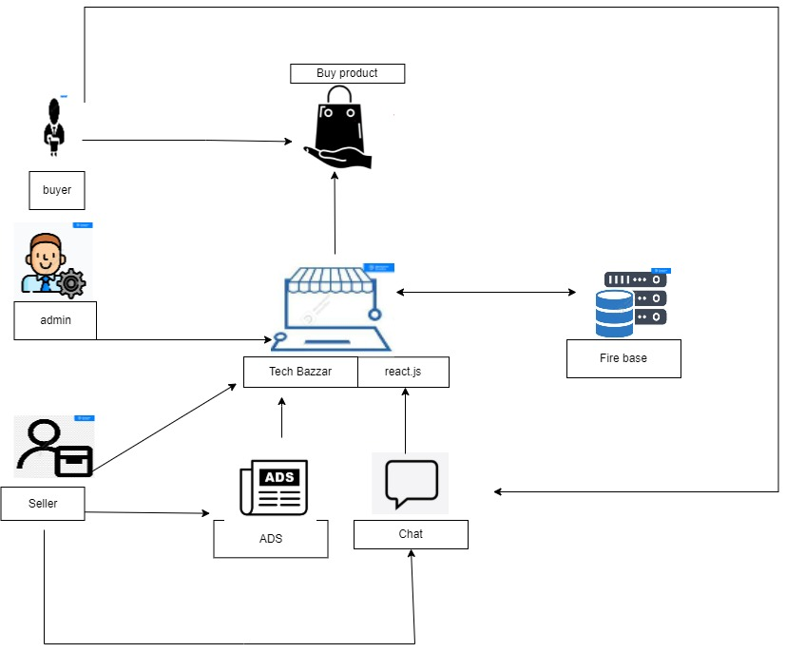

# 

# **Related Projects Drawbacks**

**Amazon:**

* Scammers
* Bad logistics (damage products during logistic process and don’t provide courier options to buyer.
* Amazon is incapable to deliver on time,
* Amazon continues to attempt to take money from bank account no idea what for or why very disappointing
* Systematic errors cause multiple credit charges on buyers.

**AliExpress :**

* Scammers in aliexpress take credits and cause loss to buyers
* Logistic system failure, false status tracking of delivery
* Cannot build good relationship between buyer and seller
* Don’t give communication messenger system for both sides

# **Tools and Technologies**

|  |  |  |
| --- | --- | --- |
| **Sr. No** | **Tools/Software** | **Detail** |
| 1. | Firebase | Dynamic, NoSQL, Flexible |
| 2. | React js | Reusability, Open Source |

# 

# **Project Scope**

Our project will be a web-based computer and electronic accessories Store for managing all types of electric and computer accessories providing an additional feature to our users of negotiation over price and quality and free interest installments.

# References

https://www.aboutamazon.com/

<https://www.britannica.com/topic/Amazoncom>

<https://www.trustpilot.com/review/www.aliexpress.com>

https://www.trustpilot.com/review/amazon-seller.co.uk